**Boeing X-37 Orbital Spaceplane: Beyond The Blue**

CLASS: ARO 3111 – Gas Dynamics & Highspeed Aerodynamics

Section #2

INSTRUCTOR: Dr. Tony C. Lin

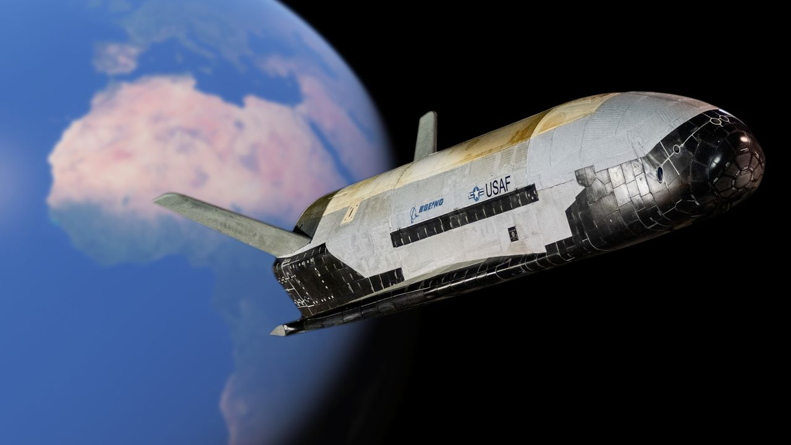

**Justin T. Millsap**

Aerospace Engineering Department

California State Polytechnic University, Pomona

March 12th, 2024

# **Abstract**

The Boeing X-37 Orbital Spaceplane represents a groundbreaking venture in the evolution of aerospace engineering Engineered by Boeing Phantom Works and operated by the U.S. Air Force, this unmanned spacecraft emphasizes the possibility of reusability, autonomy, and long-duration flight capabilities within the space mission world. Initiated by NASA in 1999 and later transitioned to the Department of Defense in 2004, the X-37 has broken new ground by being able to work both in space and re-entry back to Earth. This paper delves into the intricate design, unique aerodynamics, propulsion attributes, and the structural and material innovations that assist the X-37's operational success. With a focus on the spacecraft's configuration, this analysis highlights the significant contributions of the X-37 to high-speed aerodynamics and gas dynamics, evidenced by its long endurance in Low Earth Orbit (LEO), autonomous operations, and impact it holds for future missions. Through six orbital missions, the X-37 has not only demonstrated the practicality and strategic value of reusable spacecraft but also served as a pivotal platform for testing and validating technologies that will shape the future of space exploration and defense strategies.

# **Introduction**

The Boeing X-37 is a reusable unmanned spacecraft which was engineered by Boeing Phantom Works and is operated by the U.S. Airforce. This project was initiated by NASA in 1999, then later transferred to the Department of Defense (DoD) in 2004. The purpose of this space vehicle is to demonstrate reuseable space technology. The X-37 is the first of NASA’s reusable launch vehicles designed to operate in both orbit and re-entry. It showcases several advancements of aerospace technology such as reusability, autonomy, and long duration spaceflight. Its innovative design and successful missions have not only proven the viability of reusable space vehicles but also set a new benchmark for future space missions, potentially changing the way we approach satellite deployment, on-orbit servicing, and space exploration by significantly reducing costs and increasing operational flexibility.

**Figure 1‑1: Boeing X-37 launching from the Kennedy Space Center aboard a Falcon 9**

# **2.0 Configuration Description**

## **2.1 Three view drawing**

The three figures listed below resemble three different views of the Boeing X-37. This space vehicle is 8.9 meters long, 2.9 meters tall, and has a wingspan of 4.5 meters. Its loaded weight is 4,990 kilograms. Some key features to notice are the two swept tail fins and the lifting body design. These features are crucial in terms of the performance of the X-37’s aerodynamics.

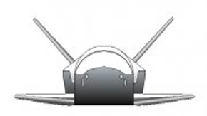

**Figure 2‑1: Front View of Boeing X-37**

**Figure 2‑2: Top View of Boeing X-37**

**Figure 2‑3: Side View of Boeing X-37**

## **2.2 Unique or Key “High Speed” aerodynamics/propulsion design attributes**

The Boeing X-37 utilizes very specific aerodynamic/propulsion design attributes such as a lifting body design, two angled tail fins, and advanced avionics & control system, The lifting body design enables the X-37 to generate lift mainly through its architecture rather than relying on traditional wings. This specific design allows for re-entry into earth’s atmosphere by spreading out thermal and aerodynamic loads over a large surface area. The two swept tail fins allow the spacecraft to glide through Earth’s atmosphere with a great amount of control during decent and landing phases. The design of these wings helps achieve lower landing speeds, minimize aerodynamic drag, and improve stability at high velocities. The avionics and control system are utilized to perform precise maneuvers in orbit, landing, and re-entry phases. During re-entry the Boeing-X37 generates bow shockwaves.

**2.3 Structures and Materials Design**

The Boeing X-37 was manufactured out of different types of metal such as composite material, titanium & aluminum alloys, high-temperature glass, & it is equipped with a thermal protection system. The choice of composite material allows the spacecraft to endure mechanical stresses that will be present during launch, orbit, and landing phases. Titanium and aluminum allow for a good balance between durability and weight. The thermal protection system and high-temperature glass allows the Boeing X-37 to endure the high temperatures during launch and re-entry.

## **2.4 Propulsion System**

The propulsion system of the Boeing X-37 utilizes a single Aerojet AR2-3 engine using storable propellants. This propulsion system can provide 700N of thrust while also providing a total delta-V of 3.1 km/s. Power is generated using a solar array which consists of Gallium Arsenide solar cells and lithium-ion batteries.

# **3.0 Performance**

## **3.1 Missions Descriptions**

The Boeing X-37 was designed in 1999 to demonstrate technologies for a reusable, reliable, unmanned space test platform for the U.S. Airforce. Most objectives are classified, but one objective was to have the X-37 rendezvous with other satellites for refuel and repairs using a robotic arm. The objective of the Boeing X-37 is to be in LEO and be able to perform flights lasting up to 270 days.

## **3.2 Performance Characteristics**

Table 3.1 displays the performance characteristics of the Boeing X-37. This spacecraft has a max Mach of 22.5 which indicates high-speed aerodynamics which enters the realm of hypersonic flight. At these speeds, factors such as shockwaves and high temperatures play a huge role. Given that one objective of the Boeing X-37 is to partake in missions up to 270 days, aerodynamic design and propulsion systems will help assist with fuel efficiency. A high specific impulse (Isp) is necessary for high-speed aerodynamics because it allows for achieving high speeds with low fuel consumption.

|  |  |
| --- | --- |
| Boeing X-37 | |
| MMax | 22.5 (28,200 km/h) |
| Range (unfueled) | 270 days |
| Thrust | 700 N |
| Paylaod | 5000 kg |
| Specific Impulse (Isp) | 280s |

# **4.0 Design & Manufacturing**

The design of the Boeing X-37 began in 1999 as a NASA project then transferred to the United States Department of Defense (DoD) in 2004. The design of the space vehicle by the Boeing Phantom Works division and the total cost of the production of the Boeing X-37 was approximately $173 million. Figure 4.1 showcases the Boeing X-37 in production.

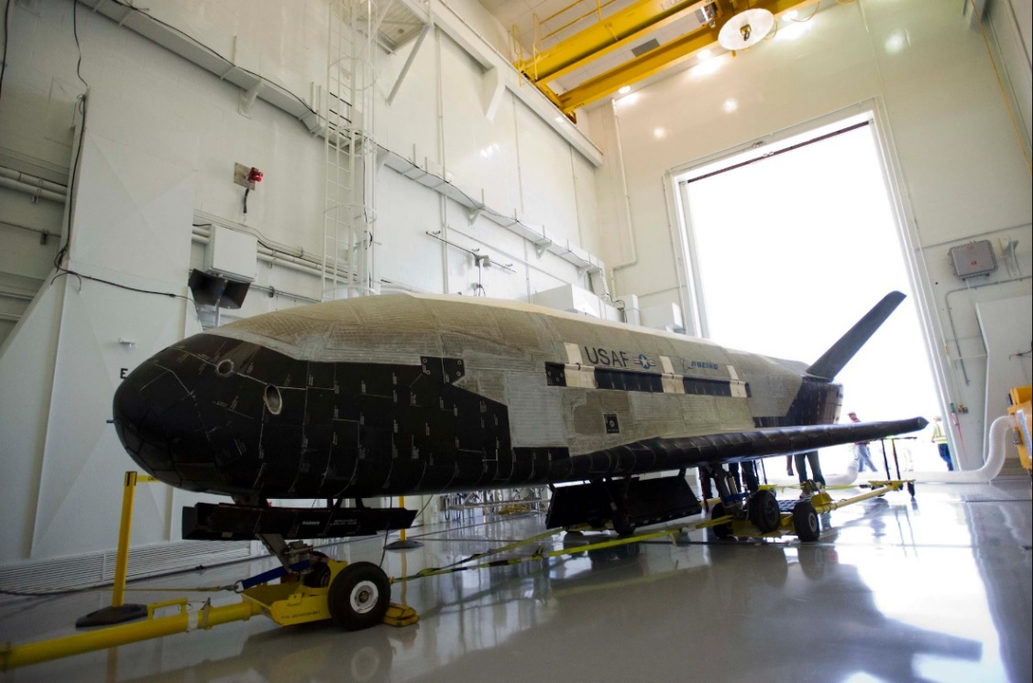

**Figure 4‑1: A showcase of the Boeing X-37**

# **5.0 Impact of the Boeing X-37 Conclusions**

## **5.1 Mission Capability achieved**

The Boeing X-37 has completed a total of six orbital missions and has spent a combined 3,774 days in space. This spacecraft has showcased the ability to conduct long-duration missions in space. This spacecraft also obtains autonomous operations as it has completed multiple missions autonomously returning to earth.

## **5.2 Impact on Future designs**

The Boeing X-37 through its Orbital Test Vehicle (OTV) missions has made many contributions to space technology. This space vehicle has demonstrated successful reuse which lowers the overall cost of future missions allowing the same vehicle to be launched, recovered, and relaunched. The X-37 also has been used to test various materials and propulsion technologies which improves the durability, efficiency, and performance of future spacecraft materials and propulsion systems.

**References**

[1] Spaceflight 101. (n.d.). X-37B Orbital Test Vehicle.

https://spaceflight101.com/spacecraft/x-37b-otv/ Boeing. (n.d.).

[2] X-37B Orbital Test Vehicle.

https://www.boeing.com/defense/autonomous-systems/x37b#purpose Secure World Foundation.

[3] (2022). X-37B Orbital Test Vehicle Fact Sheet - May 2022.

https://swfound.org/media/207377/swf-x-37b-otv-fact-sheet-may-2022.pdf Grey Dynamics.

[4] (n.d.). X-37B: America’s Spaceplane.

https://greydynamics.com/x-37b-americas-spaceplane/